Virtual Lan (VLAN)

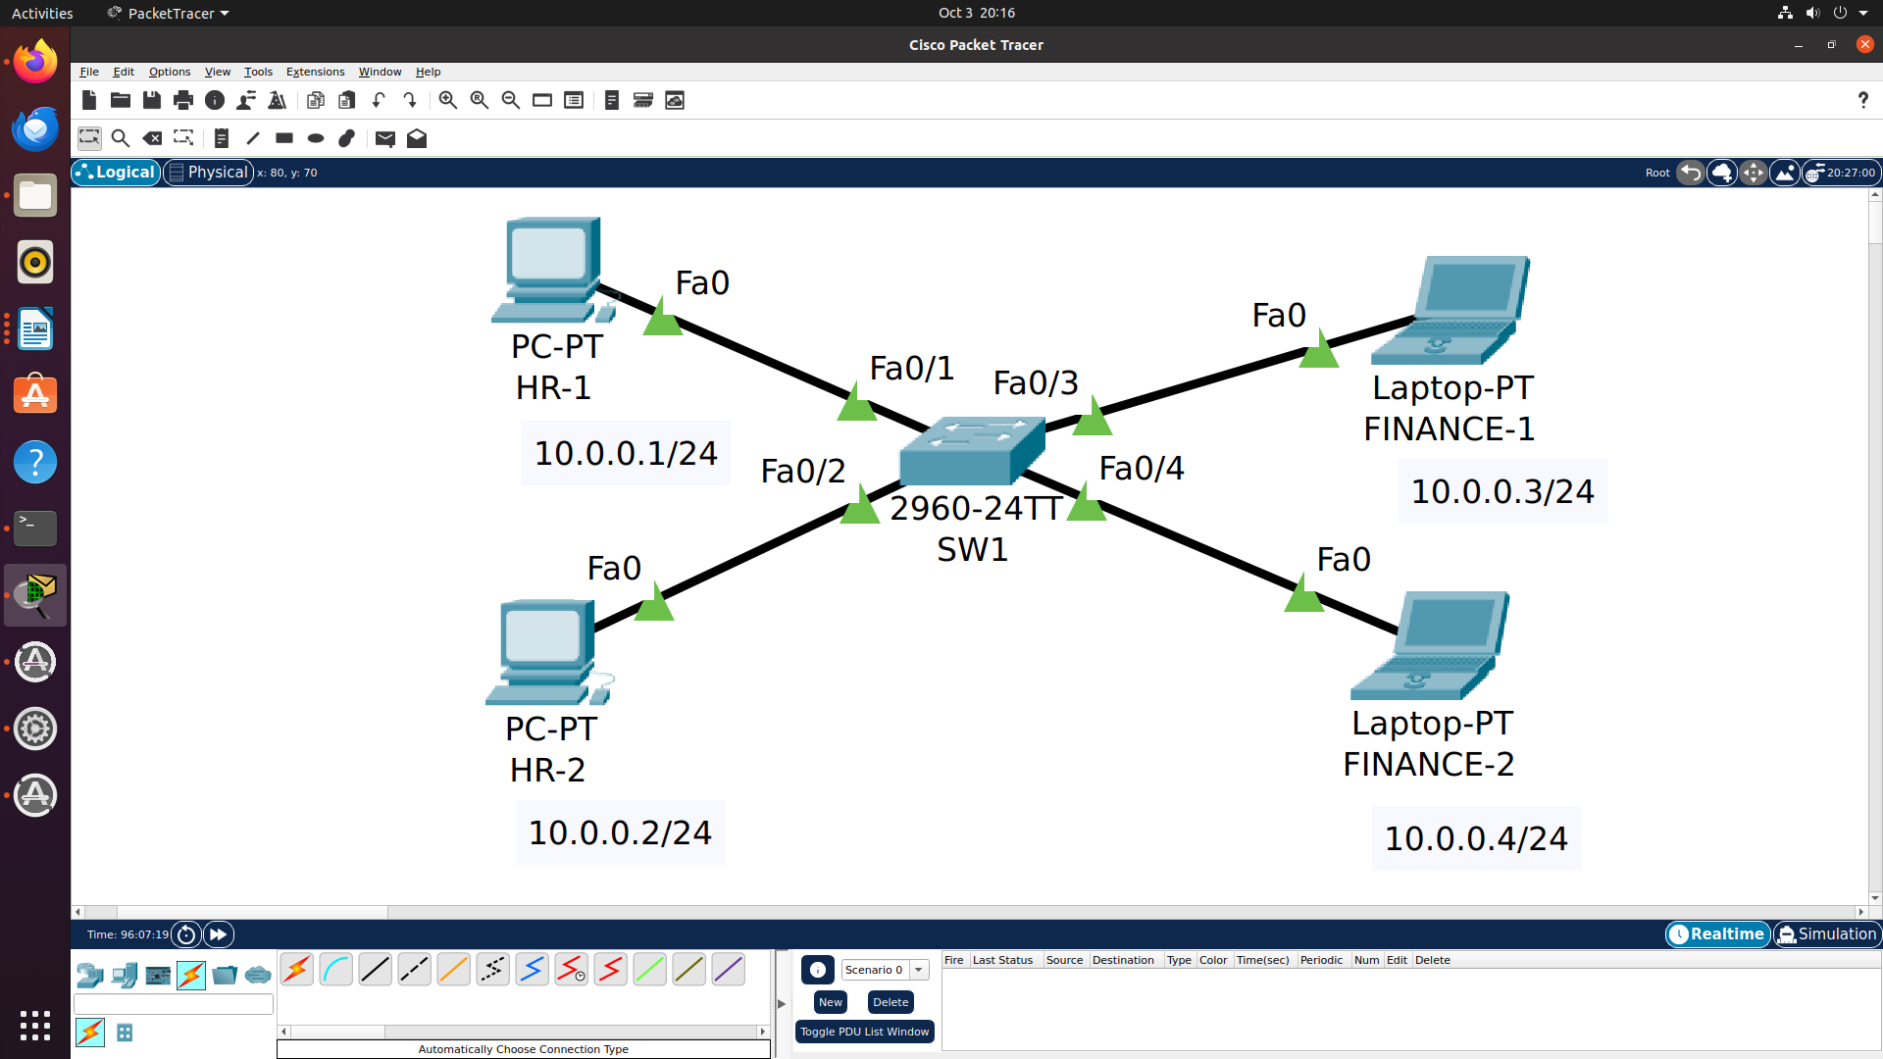

ON PCI

C:\>PING 10.0.0.4

Pinging 10.0.0.4 with 32 bytes of data:

Reply from 10.0.0.4: bytes=32 time<1ms TTL=128
Reply from 10.0.0.4: bytes=32 time=1ms TTL=128
Reply from 10.0.0.4: bytes=32 time<1ms TTL=128
Reply from 10.0.0.4: bytes=32 time<1ms TTL=128

Ping statistics for 10.0.0.4:
Packets: Sent = 4, Received = 4, Lost = 0 (0% loss),
Approximate round trip times in milli-seconds:
Minimum = 0ms, Maximum = 1ms, Average = 0ms

SW1#show vlan

VLAN Name Status Ports
---- -------------------------------- --------- -------------------------------
1 default active Fa0/1, Fa0/2, Fa0/3, Fa0/4
Fa0/5, Fa0/6, Fa0/7, Fa0/8
Fa0/9, Fa0/10, Fa0/11, Fa0/12
Fa0/13, Fa0/14, Fa0/15, Fa0/16
Fa0/17, Fa0/18, Fa0/19, Fa0/20
Fa0/21, Fa0/22, Fa0/23, Fa0/24
Gig0/1, Gig0/2
1002 fddi-default active
1003 token-ring-default active
1004 fddinet-default active
1005 trnet-default active

VLAN Type SAID MTU Parent RingNo BridgeNo Stp BrdgMode Trans1 Trans2
---- ----- ---------- ----- ------ ------ -------- ---- -------- ------ ------
1 enet 100001 1500 - - - - - 0 0
1002 fddi 101002 1500 - - - - - 0 0
1003 tr 101003 1500 - - - - - 0 0
1004 fdnet 101004 1500 - - - ieee - 0 0
1005 trnet 101005 1500 - - - ibm - 0 0

VLAN Type SAID MTU Parent RingNo BridgeNo Stp BrdgMode Trans1 Trans2
---- ----- ---------- ----- ------ ------ -------- ---- -------- ------ ------

Remote SPAN VLANs
------------------------------------------------------------------------------

Primary Secondary Type Ports
------- --------- ----------------- ------------------------------------------
SW1#

SW1(config)#vlan 10
SW1(config-vlan)#name HR
SW1(config-vlan)#vlan 20
SW1(config-vlan)#name finance

SW1#sh vlan

VLAN Name Status Ports
---- -------------------------------- --------- -------------------------------
1 default active Fa0/1, Fa0/2, Fa0/3, Fa0/4
Fa0/5, Fa0/6, Fa0/7, Fa0/8
Fa0/9, Fa0/10, Fa0/11, Fa0/12
Fa0/13, Fa0/14, Fa0/15, Fa0/16
Fa0/17, Fa0/18, Fa0/19, Fa0/20
Fa0/21, Fa0/22, Fa0/23, Fa0/24
Gig0/1, Gig0/2
10 HR active
20 finance active
1002 fddi-default active
1003 token-ring-default active
1004 fddinet-default active
1005 trnet-default active

VLAN Type SAID MTU Parent RingNo BridgeNo Stp BrdgMode Trans1 Trans2
---- ----- ---------- ----- ------ ------ -------- ---- -------- ------ ------
1 enet 100001 1500 - - - - - 0 0
10 enet 100010 1500 - - - - - 0 0
20 enet 100020 1500 - - - - - 0 0

To add ports to particular vlan 10

SW1(config)#interface fastEthernet 0/1
SW1(config-if)#switchport access vlan 10
SW1(config)#interface fastEthernet 0/2
SW1(config-if)#switchport access vlan 10

To add ports to particular vlan 20

SW1(config)#interface fastEthernet 0/3
SW1(config-if)#switchport access vlan 20
SW1(config)#interface fastEthernet 0/4
SW1(config-if)#switchport access vlan 20

SW1#sh vlan

VLAN Name Status Ports
---- -------------------------------- --------- -------------------------------
1 default active Fa0/5, Fa0/6, Fa0/7, Fa0/8
Fa0/9, Fa0/10, Fa0/11, Fa0/12
Fa0/13, Fa0/14, Fa0/15, Fa0/16
Fa0/17, Fa0/18, Fa0/19, Fa0/20
Fa0/21, Fa0/22, Fa0/23, Fa0/24
Gig0/1, Gig0/2
10 HR active Fa0/1, Fa0/2
20 finance active Fa0/3, Fa0/4
1002 fddi-default active
1003 token-ring-default active
1004 fddinet-default active
1005 trnet-default active

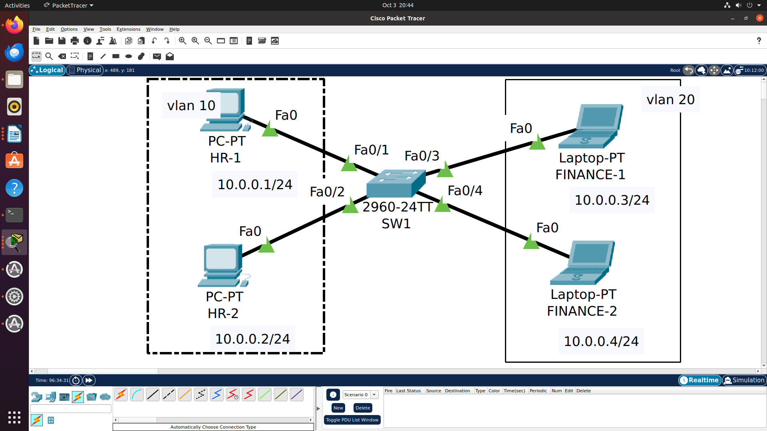

C:\>PING 10.0.0.2

Pinging 10.0.0.2 with 32 bytes of data:

Reply from 10.0.0.2: bytes=32 time<1ms TTL=128
Reply from 10.0.0.2: bytes=32 time<1ms TTL=128
Reply from 10.0.0.2: bytes=32 time=18ms TTL=128
Reply from 10.0.0.2: bytes=32 time<1ms TTL=128

Ping statistics for 10.0.0.2:
Packets: Sent = 4, Received = 4, Lost = 0 (0% loss),
Approximate round trip times in milli-seconds:
Minimum = 0ms, Maximum = 18ms, Average = 4ms

C:\>PING 10.0.0.4

Pinging 10.0.0.4 with 32 bytes of data:

Request timed out.

